**Name -: Aditya Babaso Birangaddi**

**Roll No -: 47**

**Enrollment No -: 1915770160**

**Practical No 6**

**Sample Questions -:**

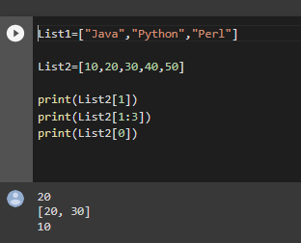

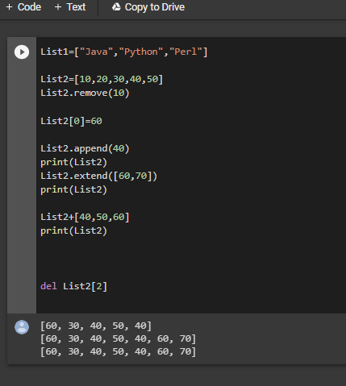

**Q1. Write a Python program to sum all the items in a list.**

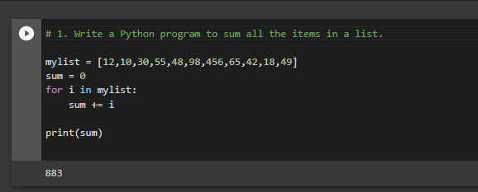

**2. Write a Python program to multiplies all the items in a list.**

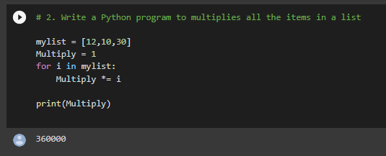

**3. Write a Python program to get the largest number from a list.** 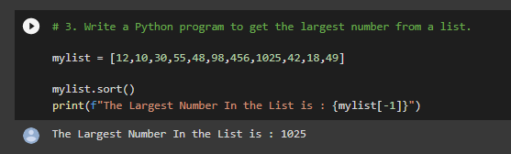

**4. Write a Python program to get the smallest number from a list.** 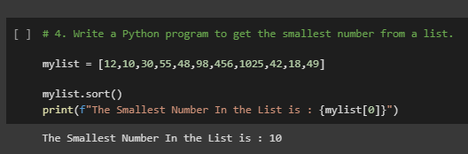

**5. Write a Python program to reverse a list.**

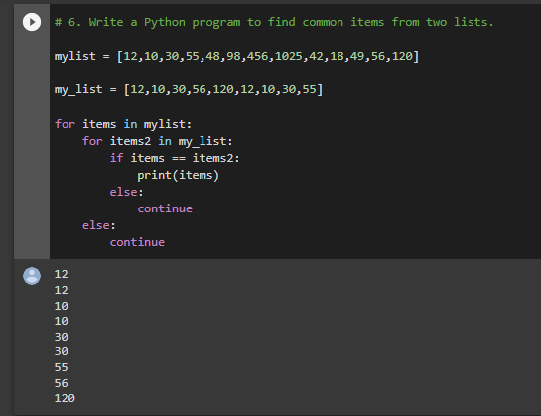

**6. Write a Python program to find common items from two lists.** 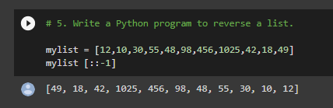

**7. Write a Python program to select the even items of a list.** 